yum install docker -y

systemctl start docker

docker run -itd --name server-1 centos bash

docker run -itd --name server-2 centos bash

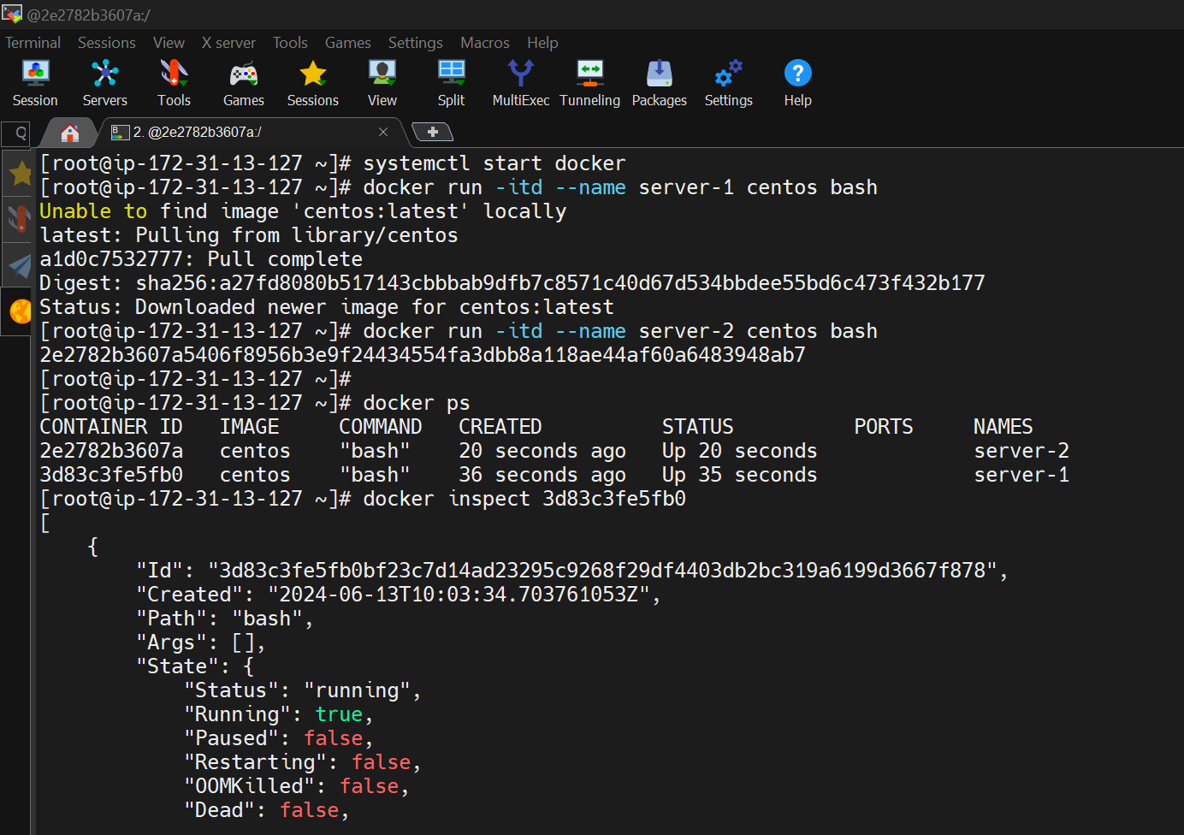

docker network create velocitynw

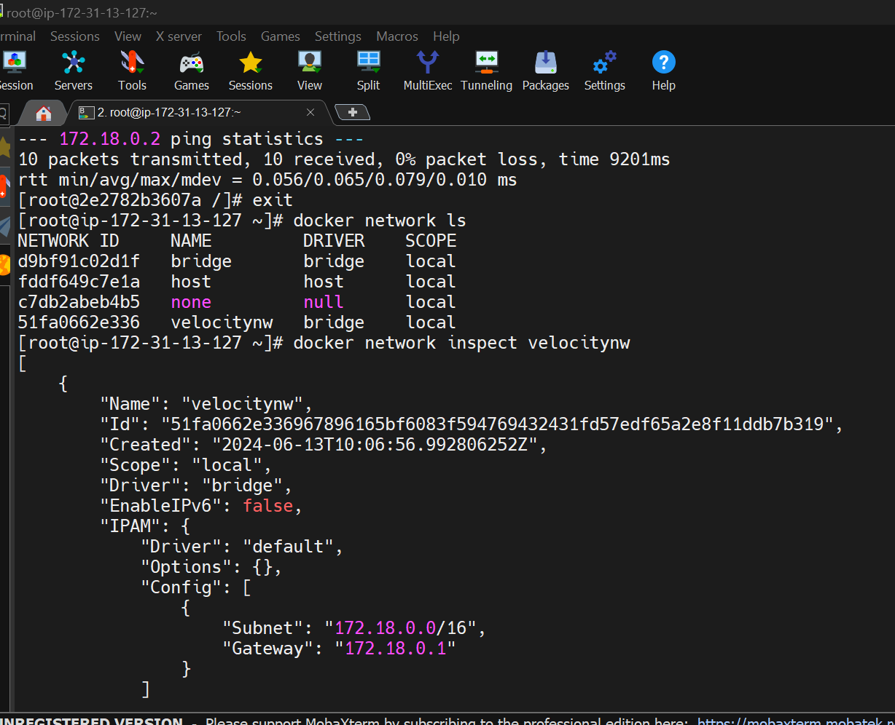

docker run -itd --name server-3 --network velocitynw centos bash

docker network connect velocitynw server-1

docker network connect velocitynw server-2

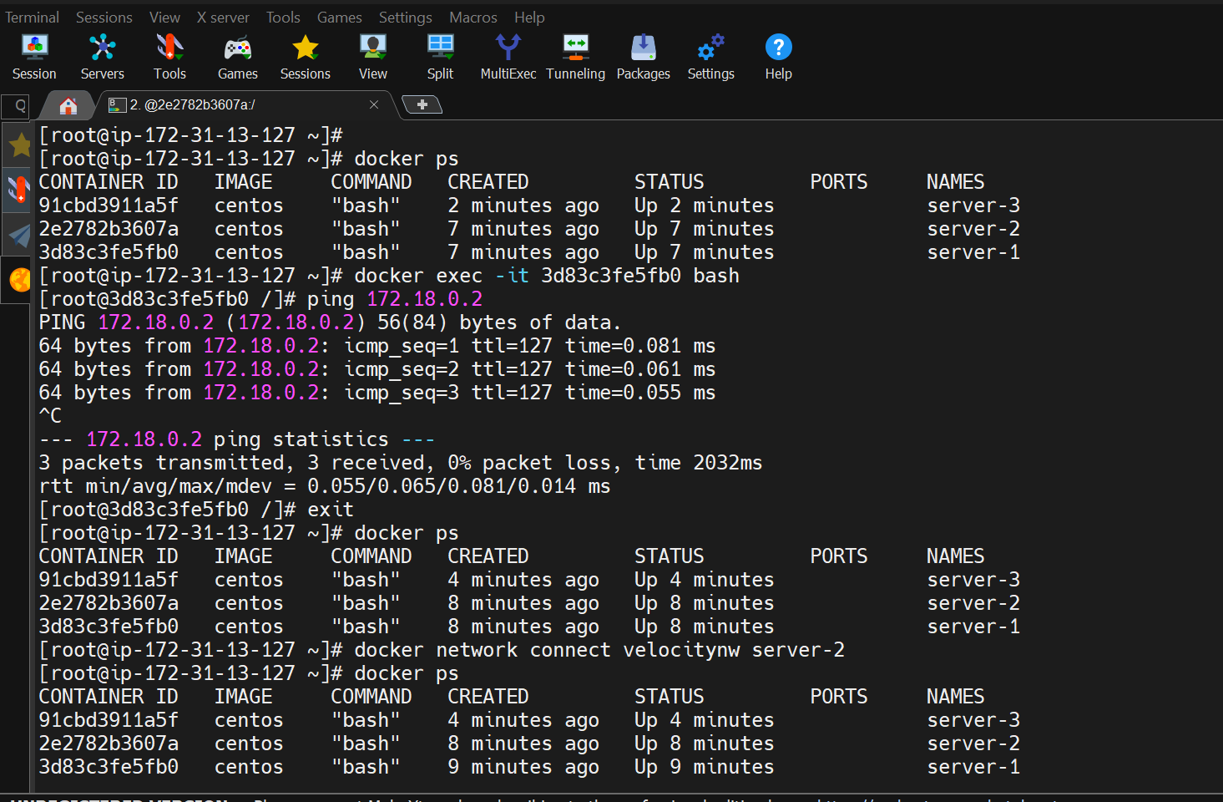



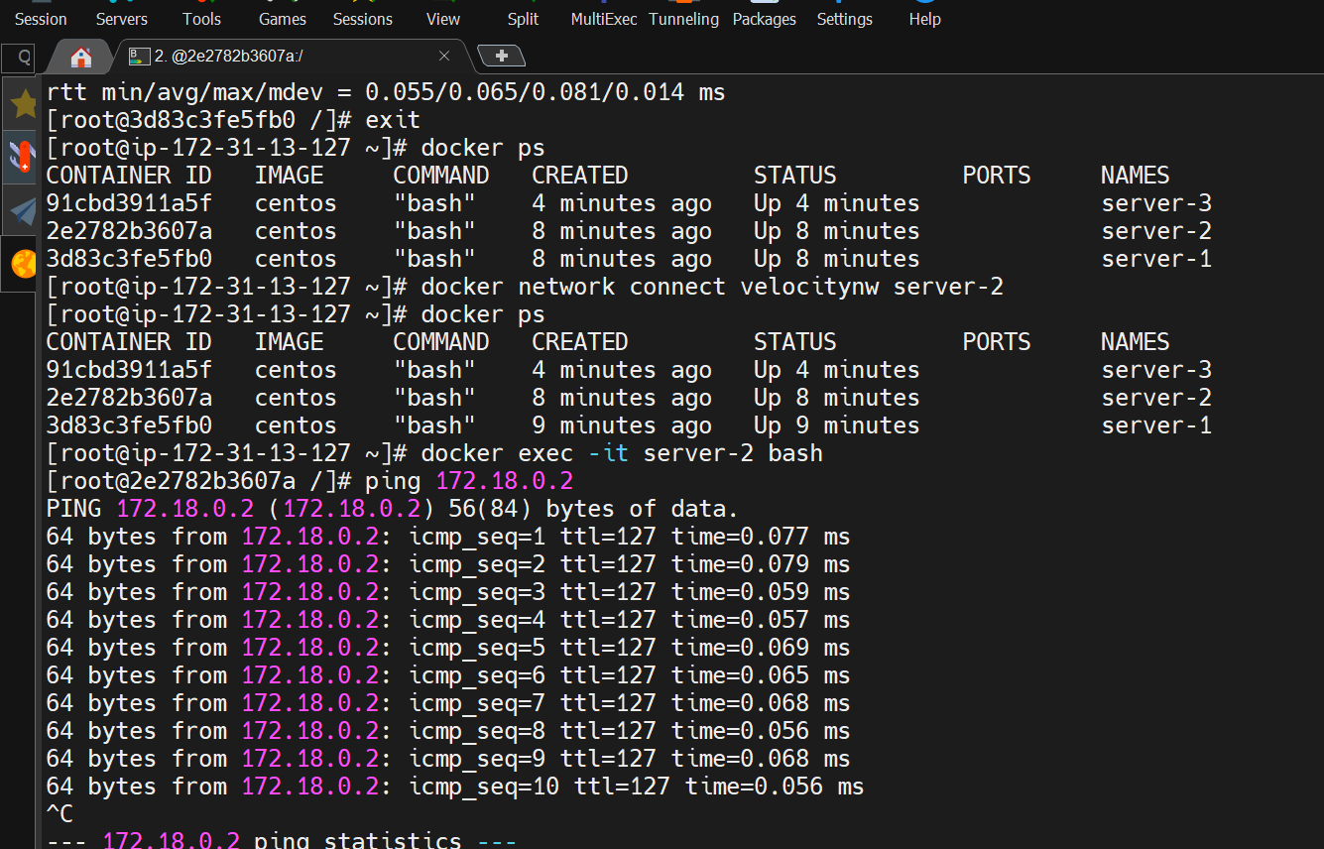

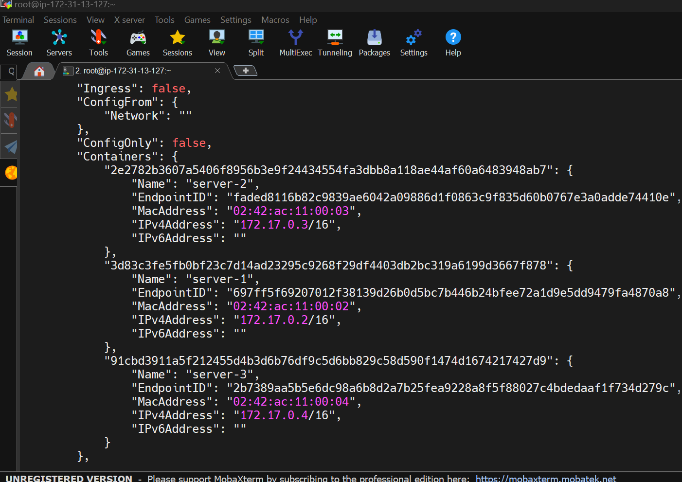

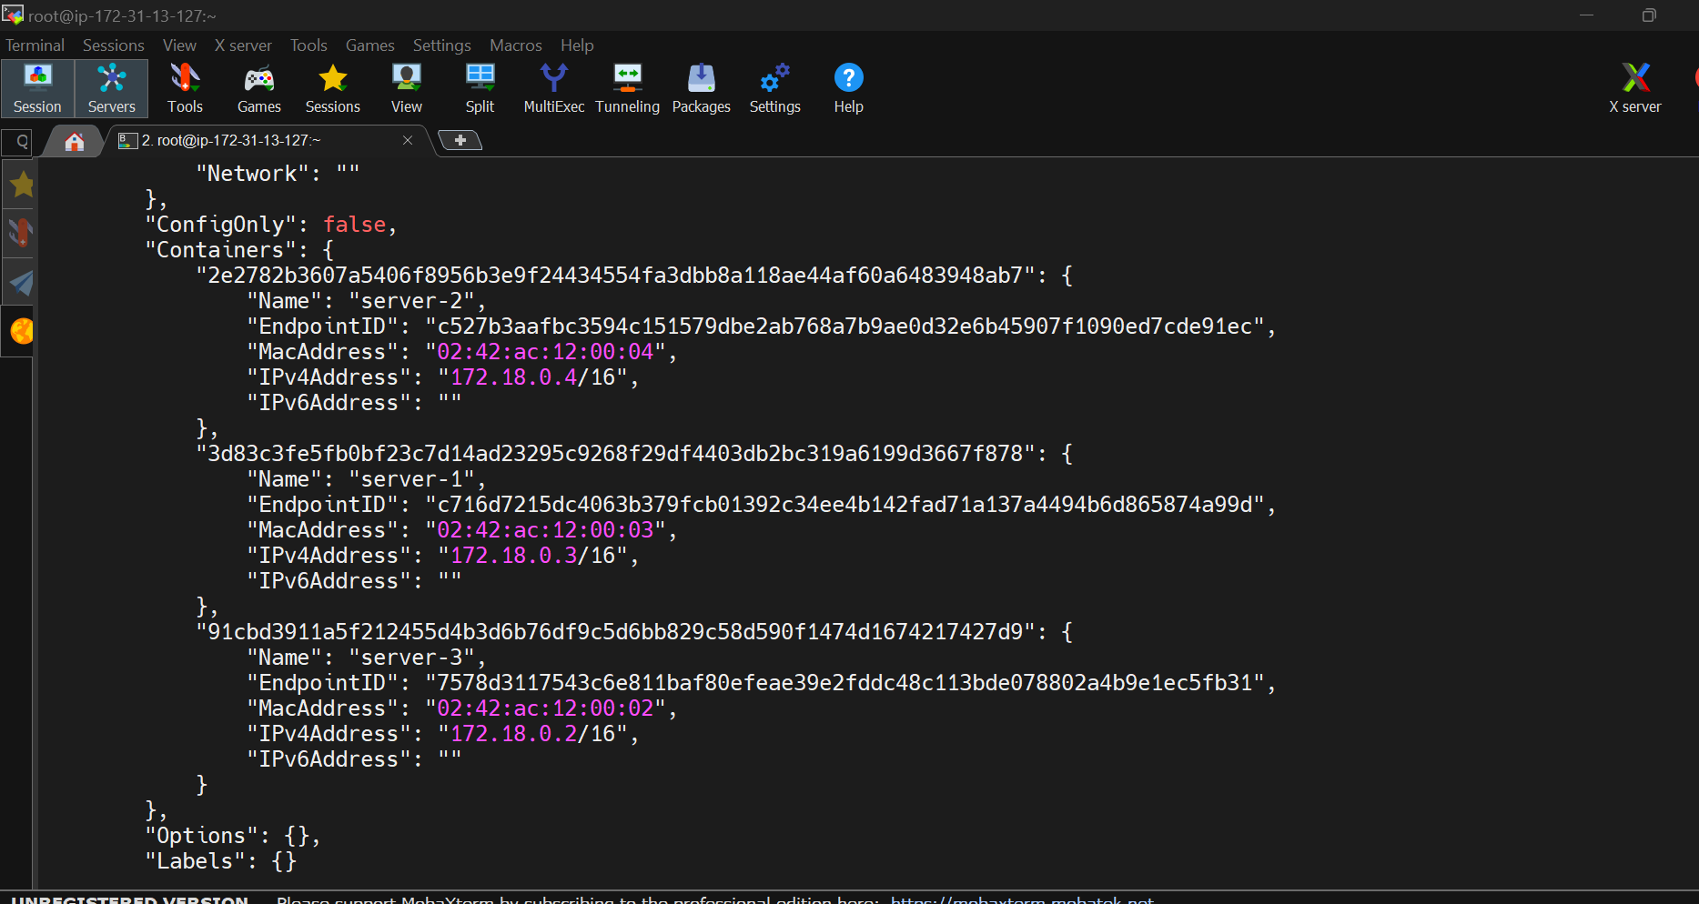

1 yum install docker -y

2 systemctl start docker

3 docker run -itd --name server-1 centos bash

4 docker run -itd --name server-2 centos bash

5 docker ps

6 docker inspect 3d83c3fe5fb0

7 docker ps

8 docker inspect 2e2782b3607a

9 docker network create velocitynw ---driver=bridge

10 docker network create velocitynw

11 docker run -itd --name server-3 --network velocitynw centos bash

12 docker network connect velocitynw server-1

13 docker ps

14 docker inspect 91cbd3911a5f |grep IPA

15 docker ps

16 docker exec -it 3d83c3fe5fb0 bash

17 docker ps

18 docker network connect velocitynw server-2

19 docker ps

20 docker exec -it server-2 bash

21 docker network ls

22 docker network inspect velocitynw

23 brctl show

24 network inspect bridge

25 docker ntework inspect bridge

26 docker ntework inspect br-51fa0662e336

27 docker network inspect br-51fa0662e336

28 brctl show

29 network inspect velocitynw

30 docker inspect network velocitynw

31 brctl show

32 docker network inspect velocitynw

33 docker network ls

34 docker network inspect d9bf91c02d1f

35 history

\*\*\*You can ping from server-1&server-2 to server-3\*\*\*

\*\*But if you want to ping form server-3 to server-1&and server-2\*\*\*

36 docker network ls

39 docker network connect bridge server-3

40 docker ps

41 docker exec -it 91cbd3911a5f bash

42 docker exec -it server-3 bash

43 history